YEAR 10 BIOLOGICAL SCIENCE
BIOLOGICAL CHEMISTRY
TITRATIONS

AIM To determine the concentration of CO₂ in a carbonated drink.

METHOD 1. Set up a burette with some 0.200 molL⁻¹ NaOH solution.

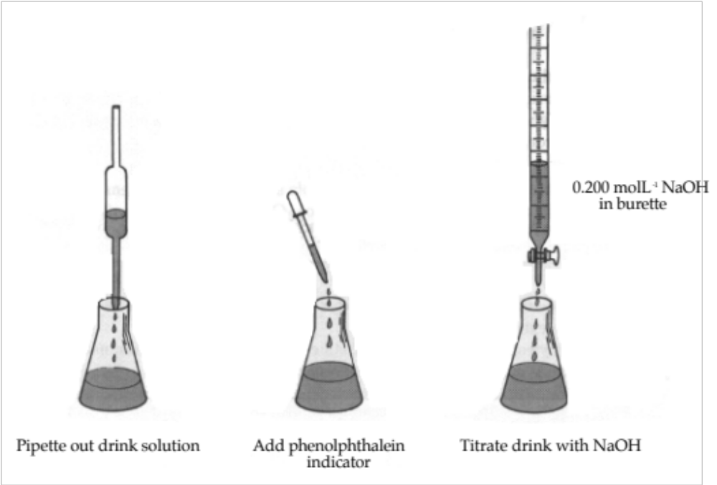

2. Record the initial level of NaOH accurately (to 2 decimal places).

3. Pipette 20.00 mL of the drink solution into a clean 250 mL conical flask and add 2-3 drops of phenolphthalein indicator.

4. Do a rough titration by running the NaOH into the flask while swirling it. Turn off the base when a colour change occurs. (This may be difficult to pick if the drink has its own colour.)

5. Record the final level of NaOH in the burette and determine the amount of base added.

6. Refill the burette if necessary with NaOH.

7. Prepare another 20.00 mL of drink solution and phenolphthalein in a clean conical flask.

8. Note the initial level of the NaOH in the burette. Run the NaOH into the flask to within 2.00 mL of the rough titration volume. Then add the acid drop-by-drop until a colour change occurs.

9. Record the final volume of the NaOH in the burette, and then the volume of NaOH added.

10. Repeat steps 7-9 for two other 20.00 mL samples of drink.

11. Average the accurate titration volumes to determine the amount of NaOH required to neutralise the drink solution.

12. Use the graph supplied to calculate the concentration of CO₂ in the drink.

RESULTS

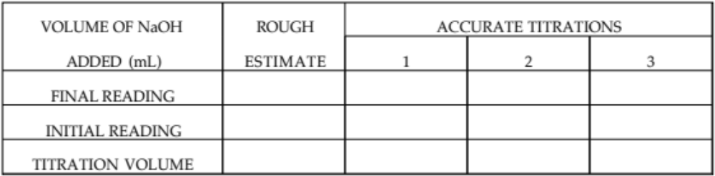

AVERAGE TITRATION VOLUME

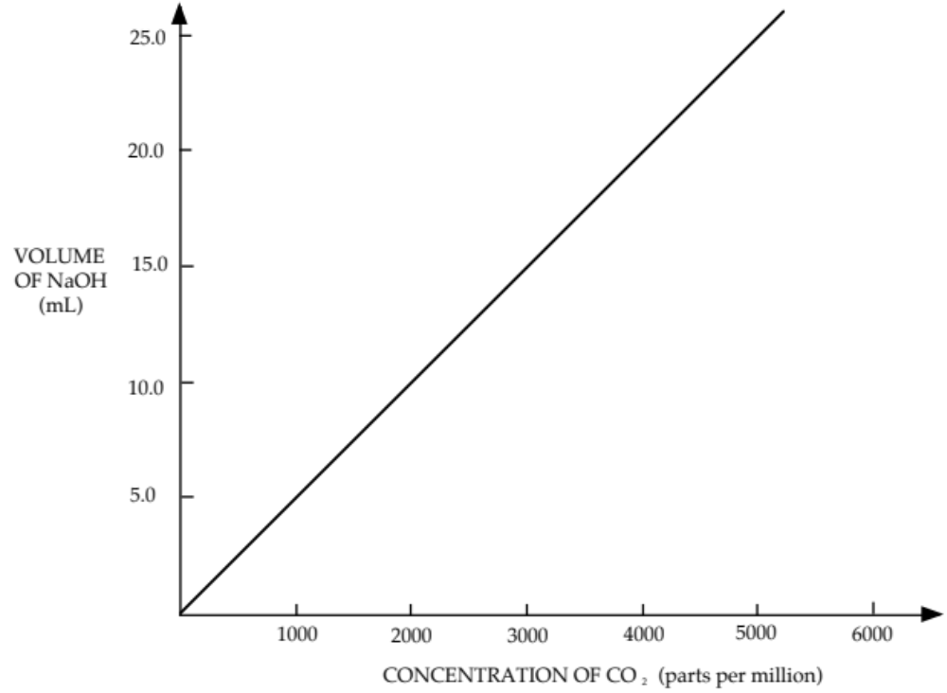

CONCLUSION

CRITICAL ANALYSIS
QUESTIONS

1. (a) Would you expect a warm sample of the drink to have more or less CO₂ in it?

(b) What does this tell you about the solubility of CO₂ in liquids?

2. Why does cold cool drink froth dramatically when poured into a warm glass from the cupboard?

3. Explain why it is not possible to use Coca-Cola in this experiment.

4. When carbonated drinks are canned, some air is removed and CO₂ is injected into the space above the liquid. Suggest a reason why the manufacturers do this.

5. (a) Why was NaOH chosen to titrate the drink solution rather than HCl?

(b) What does this tell you about the pH of a carbonated solution?

